Form 9en

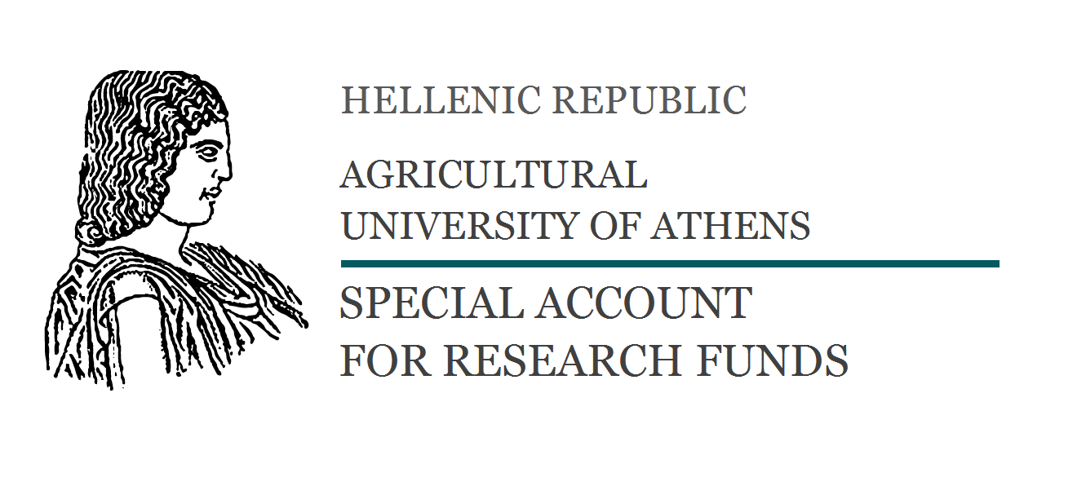

Project code:
CONTRACT AGREEMENT

In Athens, today, ..........................................................., the contracting parties:

1) Stavros Zografakis, Deputy Rector of Economic Planning, Research and Development of the Agricultural University of Athens,

2) ………………………………………..........., scientific coordinator of the project entitled:

«…………………………………………………………………………………………………………………………………………………..»
3) ........................................................., Father’s name: ………………………………….,

Occupational field: …………………………………….., City:…………………….., Address:…………………………………………… , VAT Number: ……..……..
agreed on the following:
the third of the contractors……………………………………………………...............................................................

................................................................................................................................................................

.................................................................................................................................................................

The work shall be completed within the period from ……………….. to ………….......................................

The total costs for carrying out the aforementioned task has been agreed to be € ..............................

.................................................................................................................................................................

The expenditure is subjected to all legal deductions.

The provision of services will take place in …………………………………………… Details of this agreement will be posted on the Web, as provided for in Law 3861 / 2010 (Programme “DIAVGEIA”).
This agreement was signed in three (3) copies and each contracting party received one original copy.

The contracting parties

The Deputy Rector of The Scientific Responsible The contractor Economic Planning
Research and Development

St. Zografakis …………………………… ………………………..

