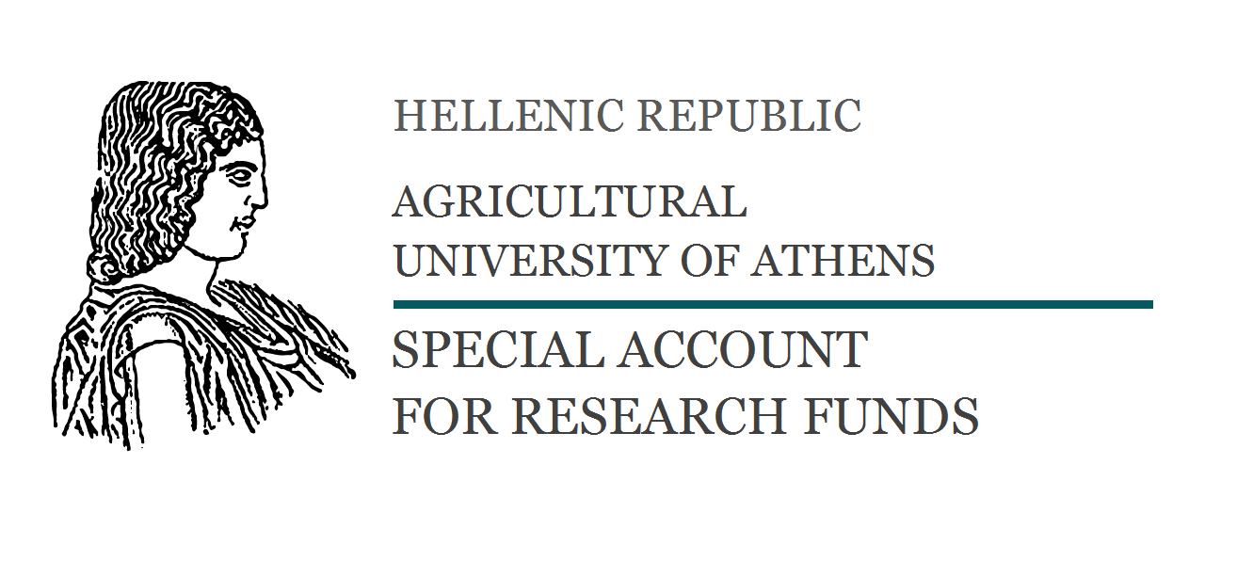
Form 44
]+[ΠΛΟΚ

CONTRACT FOR SUPPLIES AND SERVICES

Athens, Project code:

Between:

(1) Special Account for Research Funds of Agricultural University of Athens (ELKE AUA), 75 Iera Odos, 11855, Athens Greece, VAT No 090042767, legally represented by , President of Research Committee, Deputy Rector of Research, Finance and Development and Mr/Mrs , Scientific Coordinator of the Project
and
(2) the “Contractor” Mr/Mrs , legal representative of (official name and legal form of company) , (full address) , with VAT No
Having taken into consideration:
- The Research Committee of AUA has accepted the Contractor’s offer ( / - - )
- In the performance of Contract, confidentiality, avoidance of conflicts of interest with regards to intellectual property rights and timeliness are of essence.
- The provisions of law n. 4412/2016 and law n. 4957/2022.
THE PARTIES HAVE AGREED AS FOLLOWS:
- The Contractor shall provide the following services (“Services”)/ supply (“Supply”)
for the purposes of the project .
- The monitoring and control activities will be provided by the Scientific Coordinator of the Project Mr/Mrs .
- The total amount of the supply/services is fixed at € (included VAT cost) and is not subject to revision. The amounts which are due will be paid in the following manner:
% of the total amount, that is € at the countersigning of this contract, for advance payment,
% of the total amount that is €, upon issuance of the product.
- According to the current legislation (Law 4601/19, circulars 52445/23 and 78366/23), electronic invoices must be issued for the sale of goods and provision of services to the Special Account of Research Funds of the AUA through certified PEPPOL service providers.
- The work duration is ( ) months, commencing on the date of signature of the present contract.
- The supplier warrants that the products shall conform to the technical and quality standard and shall be safe, of good quality and free from any defect.
- The deadline for the warranty period is set for ( ) months from the date of the supply. During the warranty period, excluding the current maintenance, all the repairs resulting from faulty equipment will be at the supplier’s expenses, including the supply of replacement parts and the overhead costs. The supplier is to guarantee an after-sales service to ensure the maintenance service as well as the fast and regular supply of spare parts.
- Note that payments will follow the flow of project financing. In the event of a disorderly flow of funding, as would delay payments, the supplier shall continue to perform this contract without interruption. In the event of a cut money from the EU, shows a similar cut in the amount of the contract if these cuts relate to the supplier's liability actions. In these cases mentioned above, the supplier is not entitled to claim additional damages or any cancellation of the contractual obligations due to untimely payment or curtailment of the agreed fee.
- On behalf of the operational needs of the Single Independent Public Procurement Authority, in contracts covered N.4013 / 2011, Article 4, paragraph 3 and concluded after the entry into force of required withholding of 0.10 %, calculated on the value, excluding VAT, of the original contract or any amendment.
- The fee shall be paid by submitting the necessary documents.
- If the Contractor refuses to provide the services delegated to him or inadequately provided, the Research Committee of AUA may terminate this contract unilaterally and claim compensation for any damage suffered by the unconventional behavior of the second party.
- The ownership of all results generated by the execution of this contract belongs to the first party, who may make available and their use. Competent courts for the resolution of any dispute that may arise from the implementation of this sets the Athens courts.
- The “Contractor” agrees to the collection and registration of his above-mentioned personal data. The above personal data will be processed for the purpose of this agreement, in accordance with the General Data Protection Regulation (EU Regulation n. 679/2016), and will not be communicated - disclosed to third parties unless this is provided for by law or is necessary for resolving legal disputes.
- The contract was written in three (3) originals and each party received one.

THE CONTRACTING PARTIES
The President of Special Account  for Research Funds | The Contractor Company
Scientific Coordinator of the Project

