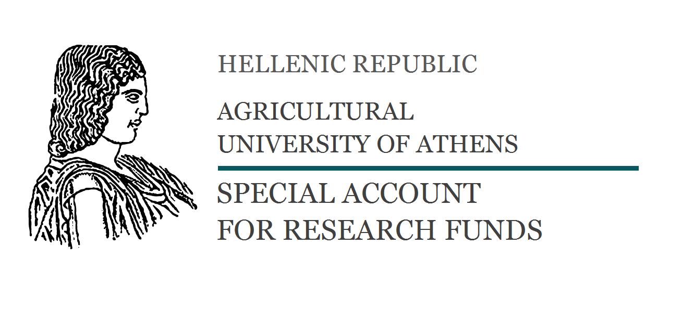
Form 32en

WORK CONTRACT

In Athens, today <date> the following contracting parties:

1. The company under the trade name <COMPANY’S TRADE NAME> and distinctive title <COMPANY’S DISTINCTIVE TITLE> , with Tax Registration Number (VAT) <XXXXXXXXX> , of the (TAX OFFICE NAME) Tax Service, and Headquarters in <MUNICIPALITY NAME> (ADDRESS P.C.) , that is lawfully represented by <Legal representative’s name> acting in his/her capacity as <Legal representative’s capacity> (e.g. Chairman, Managing Director, etc.) , hereinafter referred to as the “Employer.”

2. The RESEARCH COMMITTEE – Agricultural University of Athens, with Tax Registration Number (VAT) 090042767, of the Athens Tax Service (KEFODE ATTIKIS), and Seat in Athens (75, Iera Odos, 118 55, Votanicos), that is lawfully represented for the purpose of signing the present by Deputy Rector of Research, Economics and Development, Professor Thomas Bartzanas, hereinafter referred to as the “Contractor”,
3. (Name and title) , hereinafter referred to as the “Scientific Coordinator” of the present work

Having taken into consideration:

a) the provisions of Law 4957/2022 - Government Gazette 141/ Α / 21.7.2022,
b) <ALSO FILL-IN e.g. Board of Directors’ decision number <XXXXXXX/XX-XX-XXXX> based upon which <company name> has assigned to the Contractor the work summarized in Annex A to the present, etc>

have agreed and stipulated the following:

ARTICLE 1
Contract’s Object

By the present contract, the Employer assigns to the Contractor the implementation of the following task:
<SUMMARY OF: WORK OBJECT, TECHNICAL SPECIFICATIONS AND DELIVERABLES ASSIGNED TO THE CONTRACTOR.>

ARTICLE 2
Work Duration
The work duration is <nr.> months, commencing on the date of signature of the present contract.
The work is classified by the Scientific Coordinator as:
Research Project Provision of Service
ARTICLE 3
Contractor’s Obligations

- The “Contractor”, via the Scientific Coordinator in charge of Work, Mr./Ms <name of scientific coordinator> is responsible for successful implementation of the task vis-à-vis the Employer .
- The Contractor is expressly forbidden to transfer to any third party – physical or legal – the obligations and rights arising from the contract, unless explicit written agreement is granted by the Employer. In all cases, however, the Contractor bears full responsibility vis-à-vis the Employer for the correct implementation of Work stipulated in the contract.
- The Contractor commits him/herself to fulfil all obligations arising from this contract with appropriate care, faculty and assiduity, and in accordance with the guidelines imposed by the ethics and effective collaboration with the Employer.

ARTICLE 4
Employer’s Obligations

- The employer will take every advisable measure to facilitate the Contractor in his/her work, according to the guidelines imposed by the ethics and effective collaboration, in order to fulfil the task objectives.
- The Employer will ensure that the Contractor obtains access to the available information sources and support any Contractor efforts to acquire additional information or data required for his/her work. The Employer will also provide the Contractor with all documents the Employer deems required for the successful completion of the task, e.g. <mention of materials, data, etc. required for completion of the task>.

ARTICLE 5
Contractor’s Remuneration

- The remuneration of the Contractor for the work that he/she will execute amounts to Euro (<AMOUNT IN NUMBERS>€) plus VAT <AMOUNT IN WORDS> Euro (<AMOUNT IN NUMBERS>€) if applicable (including all legal withholdings in favour of Research Committee, and those anticipated by Law 4957/2022).
- The remuneration includes all the wages and expenses for the implementation of Contractor’s work, without any additional expense to the Employer.

ARTICLE 6
Method of payment

- The employer will pay the Contractor the agreed fee in instalments, as follows <UNLESS OTHERWISE AGREED BY THE TWO CONTRACTING PARTIES, BASED ON WHICH THE FOLLOWING WILL BE RESPECTIVELY MODIFIED >:
- 1st year payment

Payment Date | Net value | VAT* | Total
* VAT is zero, with the exception of foreign companies based in Greece that have VAT

<FILL-IN, IN CORRESPONDENCE WITH THE AGREED PAYMENT FLOW: e.g. as advance upon signature of this contract, OR as advance within XX days from the date of signature of this contract OR within the interval of [XXX] days from the date of signature of this contract, etc.>
- 2nd year payment

Payment Date | Net value | VAT | Total
* VAT is zero, with the exception of foreign companies based in Greece that have VAT

<FILL-IN ACCORDINGLY: e.g. upon delivery of Progress Report OR on date ___/___/20__. etc>

- 3rd year payment

Payment Date | Net value | VAT | Total
* VAT is zero, with the exception of foreign companies based in Greece that have VAT
< FILL-IN ACCORDINGLY: e.g. upon completion of the Work and its receipt by the Employer OR upon delivery of the Final Report OR within XX days of delivery of Final Report, etc.
The Contractor will be burdened with all third-party withholdings.

- Payment of settlement amount terminates the contractual obligations of Employer vis-à-vis the Contractor.

ARTICLE 7
Management of contractual price

- Payment will be made by the Employer to Bank Account No. 54212339 of National Bank of Greece, branch 040 and IBAN GR GR4901100400000004054212339, with beneficiary being the Agricultural University Athens – Research Committee.
- The Research Committee of the AUA will issue and provide the Employer with the corresponding receipt upon the payment of each instalment.
- The distribution of financing will be handled by the Scientific Coordinator in charge, according to the needs of the Project.
- The economic management of the Work will be handled by the Research Committee of the Contractor. For the economic management of the Work, the Research Committee withholds 15% of the net value of the contract. The Scientific Coordinator in charge is obliged to submit the corresponding receipts to the Research Committee of the AUA, according to which the respective payments will be made up to the limits set by the respective stipulated payment amount.
- Any legally entitled person/entity may check the financial supporting documents, which will be kept in the care of the Research Committee of the Contractor, and will be provided according to the provisions of Law 4957/2022 and the Contractor’s operational rovisions.

ARTICLE 8
Contract renouncement - Interruption of work

- Premature dissolution of this contract is allowed in the event of force majeure or for a considerable reason. As “Considerable Reason” that provides a party with the right to renounce the work contract, is the breach by one of the signatories (employer or contractor) of the mutually assumed obligations as stipulated in this contract.
- In the event of interruption of work, for whatever reason, or renouncement of the contract, the percentage of above-agreed fee - corresponding to the percentage of the work carried out by the Contractor up until contract interruption / renouncement - will be paid to the Contractor.

ARTICLE 9
Ownership and publication of results - Obligation of Confidentiality

- The fulfilment of Contractor’s obligations is subject to the terms of confidentiality. Throughout the term of the contract, as also after expiration of the contract validity period or the contract’s dissolution, the Contractor is not entitled to provide any third parties with any documents, data or information whatsoever that may come to its knowledge during the course of delivery of services and fulfilment of its contractual obligations.
- The intellectual property rights (copyright) and industrial property rights in relation to the Work results belong jointly to the Contractor and the Employer, which may allocate them freely, according to the law.
- The Employer is not entitled to use the name and/or logo of the Agricultural University of Athens, for purposes of advertising and/or promotion of its services and products (including those provided for in this contract), without the prior written agreement of the University.

ARTICLE 10
Applicable Law - Resolution of disputes

- This contract is governed by Greek Law.
- Any dispute regarding interpretation or application of this contract, that cannot be resolved in an amicable manner within fifteen (15) calendar days as from the receipt by one party of the other party’s pertinent request, will be resolved exclusively by the competent Athens courts.
- During the period of resolution of disputes, the contracting parts are obliged to fulfil their obligations and to exercise their rights in good faith and based on the terms of the present contract.

ARTICLE 11
Remaining General Terms

- For the proper implementation of the Work, all terms of the present contract are considered essential, and any violation thereof by a contracting party constitutes a reason for termination of the present contact by the other contracting parties.
- Total or partial judicial cancellation or declaration of any provision of the present as null and void, does not affect the validity of provisions that have not been cancelled.
- Any modification, change or complement to the present, will be carried out in writing, following agreement between the contracting parties.

After the present agreement was drawn up, read and its content was accepted by the contracting parties, the present was initialized in all of its pages, and signed by the contracting parties in five (5) original copies, three (3) of which were received by the Contractor, and two (2) by the Employer, one (1) of which will be submitted to the competent Tax Service (D.O.Y.)

THE CONTRACTING PARTIES

FOR THE EMPLOYER | FOR THE CONTRACTOR
< LEGAL REPRESENTATIVE’S CAPACITY > | < LEGAL REPRESENTATIVE’S CAPACITY >
< LEGAL REPRESENTATIVE’S NAME > | < LEGAL REPRESENTATIVE’S NAME>
THE SCIENTIFIC COORDINATOR
IN CHARGE
 | <SCIENTIFIC COORDINATOR’S NAME>
 | < SCIENTIFIC COORDINATOR’S CAPACITY>

